# 2016 年 3 月 31/4 月 2 日雅思机经预测——全套小范围

# ●雅思机经预测适用时间：

2016 年 3 月 31 日与 4 月 2 日

4 月 16 日、4 月 21 日、4 月 30 日考试的考生可提前参考本预测，相邻考试预测范围相差不大。

5 月的考试预测会有一定幅度的调整。

每场考试都有预测，会在其前一场考试结束后的 1-2 日内发布

# ●机经预测适用类别：

普通雅思 A 类考试与用于英国签证及移民的雅思考试（IELTS for UKVI）

# ●预测发布时间：

2016 年 3 月 20 日（一般预测发布时间是在其前一场考试结束后的 1-2 日）

# ●预测使用说明：

参考过去考过的题目对参加考试是有帮助的，这也是剑桥出版剑桥雅思全真试题（Past Papers）的原因。 通过以前的考试获取考试的重点，是一种聪明的学习方法。预测可以告诉你哪些考点还有可能被考到，这 样就可以在复习过程中做到有重点的学习。

**前次考试回顾 REVIEW**

2016 年 3 月 19 日考试回顾

■ 听力

↘Section 1 = 儿童活动中心咨询

↘Section 2 = 城市导览

↘Section 3 = 学生找教授商讨错过的课程 V30072s3 **预测命中**

↘Section 4 = 第一艘蒸汽船 V30037s4 **预测命中**

■ 阅读

↘Passage 1—早期城市

↘Passage 2—小提琴 **预测命中**

预测原文（阅读预测倒数第二排）：



↘Passage 3 —多任务处理

■ 写作

Task1: Bar chart **预测命中**

Task2: Some people think healthcare should be made free for all people, while others believe people should pay for healthcare by themselves. Discuss both views and give your own opinion.

■ 口语

各地区题目不同，具体请关注各地区口语回忆。 **临近考前预测 FORECAST**

**阅读预测**

阅读机经使用说明：以下阅读预测的内容都是雅思阅读真题的题目或文章主要内容，给出这些题目就是要 求考生提前对文章的背景有简单的了解。比如 Ambergris（龙涎香），如果考生不没有见过这个单词，看 文章自然是云山雾罩；如果你提前了解了 Ambergris（龙涎香）这个东西，知道龙涎香是抹香鲸科动物的 肠内分泌物制成的香料，你在阅读的时候就能大大提高效率和理解能力，为你的阅读加分！所以，你只需 要简单查阅百度百科，了解这些奇怪的概念并认识其英文名称，即可。 阅读的提高可以通过对剑桥雅思真题的研习和大量做题实现。阅读方法可使用剑桥雅思 8、9 并结合凉月 与新东方雅思名师联袂撰写的《剑桥雅思全真试题 *8* 原版解析》及《剑桥雅思全真试题 *9* 原版解析》两本书，里边详细分析了各类阅读题型的解题方法，并详细介绍了如何定位、阅读顺序、各类题目的技巧等等内容。阅读题目训练可以选用刘洪波老师编写的《雅思阅读真经 5》，全部都是雅思真题汇集，里边的题 文章可能在考试中出现。

# 机经版本预测（表格上部的 Highlight 版本为近期很可能出现的重点版本，应重点关注。划去的版本为 今年已经命中的，一般不会重复考，不必再看）：

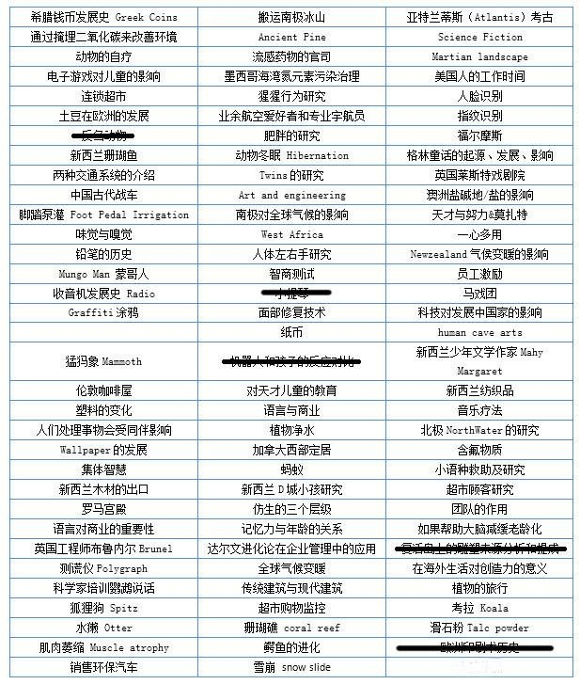

**写作预测**

小作文重点关注 **Table** 以及**地图题或流程图**，其次关注 **Bar** 和 **Pie**。其中如果考到地图题则必考城镇变 化类（详细参考《向雅思流程图说 YES！》（第二版）P63 地图题的类型，以及 P143Sample14、Sample15 的范文），流程图关注单向流程图，参照玻璃瓶的回收。 大作文重点是**教育**和**政府投资**，另需关注科技改变生活和职业发展与就业，并通过练习预测的写作题目予 以强化。

|  |  |  |  |  |
| --- | --- | --- | --- | --- |
|  | **可能性最大的题型** | | | |
| **A 类 Task1** | **Bar 35%** | **地图&流程图 30%** | **Bar 25%** | **Pie 10%** |
| **A 类 Task2** | 教育 | 政府投资 | **科技改变生活** | 职业发展与就业 |

相关练习题目：

1. Category: 教育

Some people think that people who read for pleasure acquire better imaginations and language skills than those who prefer to watch TV. To what extent do you agree or disagree?

1. Category: 政府投资 教育

Government should invest more in teaching science than other subjects such as arts, because science could contribute to the country’s development and progress. To what extent do you agree or disagree?

1. Category: 教育 科技改变生活

Universities are now offering qualifications through distance learning from the Internet rather than teachers in the classroom. Do you think the advantages of this development outweigh the disadvantages?

1. Category: 社会 工作于职业

Countries with a long average working time are more economically successful than those countries which do not have a long working time. To what extent do you agree or disagree?

1. Category: 育儿

In some countries, the parents expect children to spend long time in studying both in and after school and have less free time. Do you think it has positive or negative effects on children and the society?

1. Category: 城市建设 文化

In the past, buildings often reflected the culture of a society but today all modern buildings looks alike and cities throughout the world are becoming more and more similar. What do you think is the reason for this, and is it a good thing or a bad thing?

1. Category: 就业

Nowadays in many countries after leaving schools, the youngsters are hard to find jobs. What problems would the youth unemployment cause for the individual and for the society? What measures should be taken to reduce the level of youth unemployment?

1. Category: 旅游

Nowadays it is easier and more affordable for people to visit other countries, is it a positive or negative development?

1. Category: 就业

Nowadays many young people in work force change their jobs or careers every few years. What do you think are the reasons for this? Do the advantages outweigh disadvantages?

1. Category: 健康

Science tells us some activities are good for our health and there are some unhealthy activities. But millions of people still so those unhealthy activities. Why? What can we do to change this situation?

1. Category: 社会 职业

More and more companies are allowing employees to work at home. Do you think this is a positive or negative development?

1. Category: 社会 文化

Many museums charge people for admission while others are free. Do you think the advantages of charging people for admission to museums outweigh the disadvantages?

1. Category: 环境 社会发展

Pollution and other environment problems are resulting from a country’s development and becoming richer, some think this cannot be avoided. To what extent do you agree or disagree?

1. Category: 多元文化 国际合作

Countries are much more interesting and develop more quickly when their population includes a mixture of different nationalities and cultures. To what extend do you agree or disagree?

1. Category: 贫富差距

The gap between the rich and the poor is becoming wider, the rich richer and the poor even poorer. What problems can the situation cause and give the solutions.

1. Category: 教育 语言学习

As part of education, students should spend a period of time studying and living in a different country to learn language and culture. Do you agree or disagree?

1. Category: 老龄化

As the proportion of the older people is steadily increasing, discuss the positive or negative effects on the society.

1. Category: 文化

We living in cities or towns which have museums displaying historical and cultural importance, but people do not visit them. Why some people don’t visit museums in their local areas? What is important of museums to the society?

1. Category: 社会 生活

Nowadays people prefer throwing the broken things away and buying new ones, but people used to repair broken things in the past. Why is that and give your opinions.

# 口语预测

■ Task2 需要注意的题目（除图片上的内容外）：

1. 描述一个做过的梦

2. 描述第一次说外语的经历

3. 对于自拍的描述

4. 一个被污染过的地方 口语题目由于较多且较琐碎，考生朋友请尽量全面地准备。

经过多年预测后，我们发现，口语预测其实不如参考考试当日的回忆。比如，甲 16 日 11:30 考试，他的

题目很可能就是乙 15 日 14:00 考过的题目（有充分时间可以登录 3G 分享回忆），也可能是丙 16 日 9:30

考过的题目。在全面准备后，如果能在考前得知题目，用 30 分钟左右迅速组织语言，也能够对考试成绩 有临时的提升。

口语预测

Part 1

基本信息：

Name

Hometown

Work

Study

Major

Home

兴趣爱好

Hobby

Spare time

Sport

Swimming

Photos

Painting

Collections

Dancing

Drawing an art

Transportation

Math

个人偏好

Best time

Relaxation

Efficient times

Colors

Number

娱乐方式

Reading books

Newspaper

Magazine

TV program

Music

Movie

Museum

Concert

Art gallery

通讯与资讯

Computer

Internet

Letters

Handwriting

Mobile phones

Email

News

出行

Traveling

Airplane

Car

Map

Move to another city

语言

Language

交际

Family

Neighbor

Friends

Relatives

Teamwork

节日与集会

Holiday

Parties

Wedding

饮食与健康

Food

Cooking

Sleeping

Fruit &vegetables

Keep healthy

Snacks

时尚

Fashion

Clothing

Bags

地点

Living place

Sea

Park

自然与动植物

Weather

Birds

Animals

Pets

Plants

Trees and forest

Rain

礼物

Flowers

Gifts

生活

Happiness

Money

Being in a hurry

Stay up late

Housework

Stay alone

礼貌

Mannered

Polite

Punctuality

其他

Concentrate

Dictionary

Advertisement

Noise

Part 2

亲人/熟人

Parent

A neighbor you know

A friend

A child

具备某类特质的人

An old person

Someone you know who are very polite

Someone you enjoy talking with

A person who is good at cooking

A good leader

A person who like traveling by train

明星/要人

A person with an important job

A famous artist in your country

A person you don’t like but have to be friendly to

事件/经历

过去的

A wrong decision someone made

An important occasion you were late

Your plan in the future

A decision you regret about

A game you played in your childhood

An advice you have received

A message you received

A happy event

A perfect holiday

A special meal

A picnic

A party

A training session or a lesson you enjoyed

A mathematics class you had in your primary school

A show or performance

A family event

A leisure activity near the sea

An occasion you lost your way

A situation that others lie to you

A long journey you traveled by car

近期的

A recent change in your life

A subject you interested in now

将来的

An ambition you have not achieved yet

Your plan in the future

An exciting sport you would like to do in the future

地点

A place you would like to study and work

A crowded place

A room in which you spend a lot of time

A cafe in your hometown

A beautiful/ideal house you have visited

A place near water

A shopping mall

An interesting country

A country you have never been to but you want to go

A street that you know

物

具体的

A piece of useful electronic equipment (not computer)

An important plant in your country

A dish you like the best

A movie or book about the future

A film you want to watch again

Fruit or vegetable you like

A vehicle you’d like to buy

A type of cloth you like

A gift you gave to a person

A wild animal you know

An interesting public building

An unusual building

A family photo

A book you’d like to read again

An art or a craft you made at school

抽象的

A useful website

A language you’d like to learn

A rule at school you agree or disagree with

A good news from TV or internet

An interesting news

A song meant a lot to you

A historical event

A white lie

A type of music popular in your country

A radio program

The most popular sport in your country

A new law

A TV program